Ice 9 – Saturday August 17 9 to 10 AM Selkirk

Practice Objective
Individual skills

Timeline
Time | Allotted  (min) | Phase | Drill | Details | Goalie
9:00 | 8 min | Individual Skills | Crossover escape |  | Face shot
9:08 | 8 min | Individual Skills/Compete | Triangle pivot |  | Face shots
9:16 | 8 min | Individual Skill | Ricky Bobby |  | Face Shots
9:24 | 6 min | Individual Skills | Zombie Puck infection |  | Dekes
9:30 | 20 min | Scrimmage

Drill #1 – Crossover escape | Coach: one coach each end to control flow | Time: 8 minutes
Goalie Purpose: face shots |  | Work/Rest Ratio: high intensity low rest
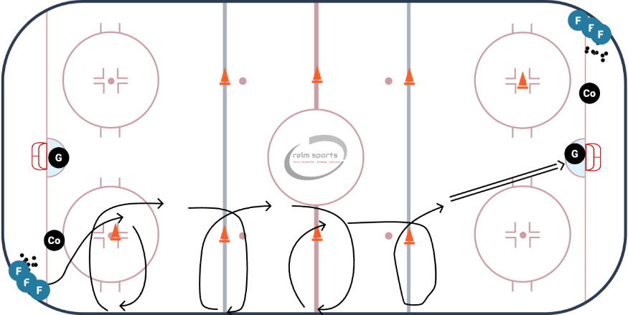
Description:
Skaters start in the corner
- Curl around the cone towards the boards,
- When they reach the boards, they crossover escape and curl around to the next cone
- Repeat and finish with a shot

WHY? | Work on generating speed and using crossovers to escape
Key Teaching &  Execution Points: | Quick/explosive crossovers, cup the puck

Drill #2 – Triangle pivot | Coach: one coach each end to control flow | Time: 8 minutes
Goalie Purpose: face shots |  | Work/Rest Ratio: high intensity med rest
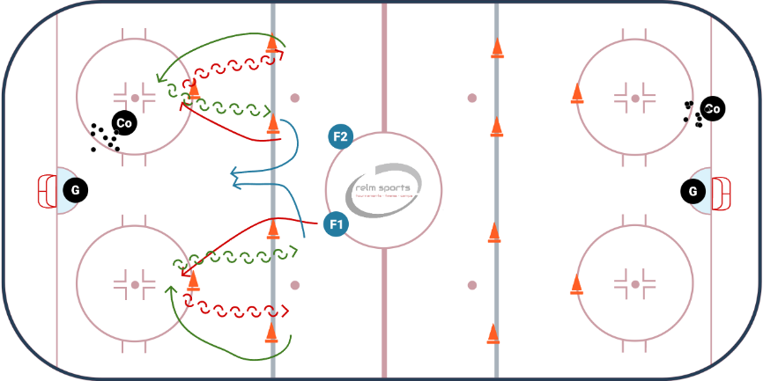
Description:
Skaters start in the center circle
- Forward around the inside cone, to the bottom cone. Pivot to backwards
- Skate backwards to the board side cone. Pivot to forward
- Skate to the bottom cone and pivot to backwards
- Skate backwards to the middle cone, and pivot to forward
- Race to the puck.

WHY? | Work on transition skills (pivot) and explosiveness
Key Teaching &  Execution Points: | Review mohawk pivot and heels/butt for fwd to back pivot

Drill #3 – Ricky Bobby | Coach: one coach each end to control flow | Time: 8 minutes
Goalie Purpose: face shots |  | Work/Rest Ratio: med intensity high rest
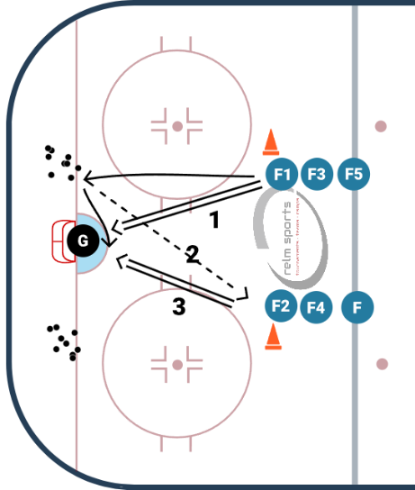
Description:
Two lines
First player starts off with a shot
- Once the player (F1) has shot the puck. They skate to their puck pile on their side
- They retrieve a puck make a pass to the first player in the adjacent line (F2)
- That player catches the puck and immediately shoots a puck that F1 tries to deflect or get a rebound.
- F2 repeats the process that F1 did, with F3.

WHY? | Work on passing to the slot and quick shot release and deflections/rebounds
Key Teaching &  Execution Points: | Review passing technique and body positioning for shooting

