Ice 8 – Friday August 1 6 to 7 PM Selkirk

Practice Objective
Skating and neutral zone regroup

Timeline
Time | Allotted  (min) | Phase | Drill | Details | Goalie
6:00 | 12 min | Individual Skills | Full ice skating with  1) Stops and starts  2) Tight Turns  3) Pivots | Once without and Once with the puck each.  2 lines if goalies (and finish w/ a shot), 3 or 4 lines if not | Face shot/stretch
6:12 | 10 min | Individual Tactic | 2 v 2 Regroup |  | Face shots
6:22 | 8 min | Individual Skills | Zombie Puck infection (king of the hill) | 2 reps | Face shots/dekes
6:30 | 20 min | Scrimmage

Drill #2 – 2 v 2 Regroup | Coach: one coach to control flow | Time: 8 minutes
Goalie Purpose: face shots |  | Work/Rest Ratio: high intensity med rest
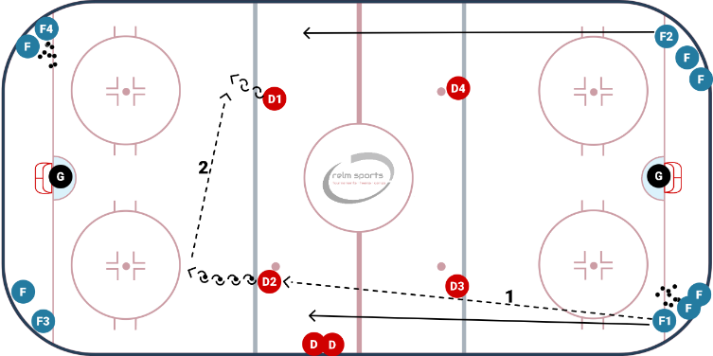
Description:
- Pucks in opposite corners. Player makes a pass to the opposite blue line. D skates backwards with the puck and opposite D also matches and moves back to catch a D to D pass
- Forwards skate up ice and curl around the opposite blue, catches a pass after the curl
- Forwards come up 2 vs 2 on the opposite side D
- repeat

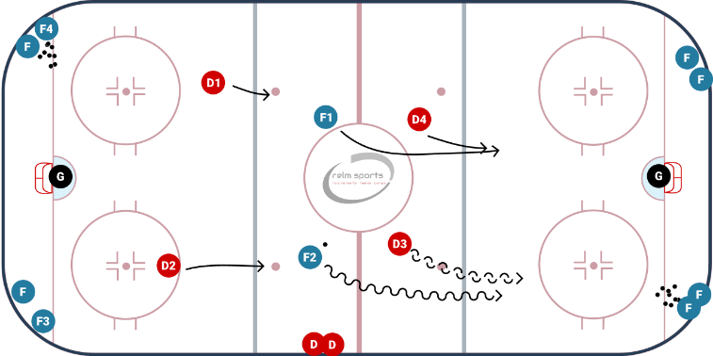
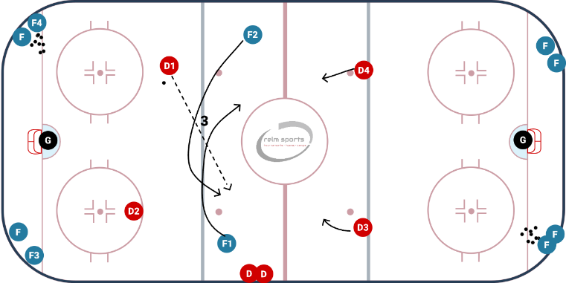
WHY? | Work on regrouping and generating speed through the neutral zone
Key Teaching &  Execution Points: | Make firm stretch pass  D create space in regroup  F generate speed through the neutral zone  Open F work to create a passing lane or rebound opportunity

