Ice 7 – Sunday July 27 Desjardin 8:30 -9:30 AM

Practice Objective
Work on puck protection and offensive zone control

Timeline
Time | Allotted  (min) | Phase | Drill | Details | Goalie
8:38 | 8 min | Warmup | Cross over Circles
 | 2 min |  | 2 hard laps - water
8:40 | 7 min | Individual Tactic | 3 cone stretch pass |  | Face shots
8:47 | 10 min | Individual Tactic | 2 v 2 Regroup |  | Face shots
8:57 | 23 min | Scrimmage |  |  | Face shots

Drill #3 – 2 v 2 Regroup | Coach: one coach to control flow | Time: 8 minutes
Goalie Purpose: face shots |  | Work/Rest Ratio: high intensity med rest
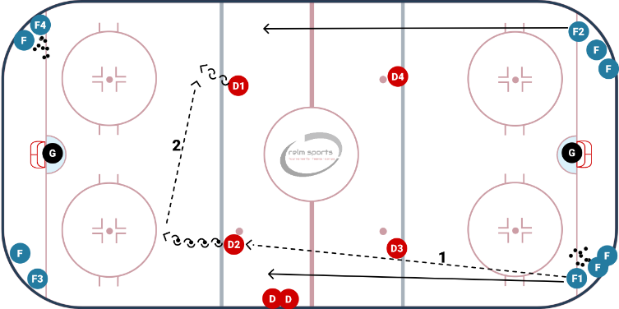
Description:
- Pucks in opposite corners. Player makes a pass to the opposite blue line. D skates backwards with the puck and opposite D also matches and moves back to catch a D to D pass
- Forwards skate up ice and curl around the opposite blue, catches a pass after the curl
- Forwards come up 2 vs 2 on the opposite side D
- repeat

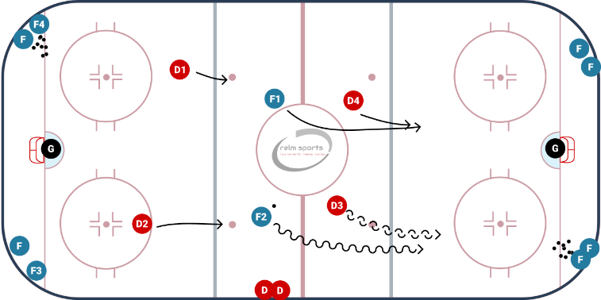
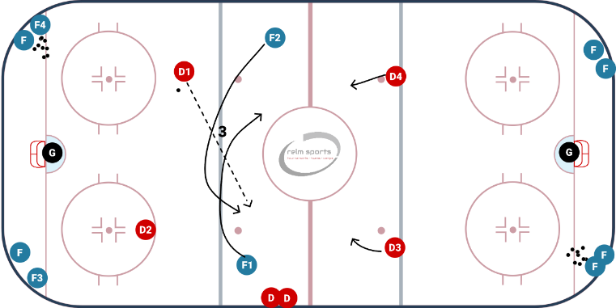
WHY? | Work on regrouping and generating speed through the neutral zone
Key Teaching &  Execution Points: | Make firm stretch pass  D create space in regroup  F generate speed through the neutral zone  Open F work to create a passing lane or rebound opportunity

