Ice 6 – July 19 Selkirk 9 to 10 AM

Practice Objective
Work on puck protection and offensive zone control

Timeline
Time | Allotted  (min) | Phase | Drill | Details | Goalie
9:00 | 7 min | Warmup | Chicago 5 puck |  | Face shots
9:07 | 8 min | Individual tactic | Olympic Breakout drill |  | Face shots
9:15 | 8 min | Individual Skill | 2 vs 0 Continuous Backcheck drill |  | Face shots
9:23 | 5 min | Conditioning | Windsprints |  | Face shots
9:28 | 22 min | Scrimmage |  |  | Face shots

Drill #2 – Wrap puck Drill | Coach: One coach per station | Time: 8 minutes
Goalie Purpose: face shots |  | Work/Rest Ratio: med intensity med rest
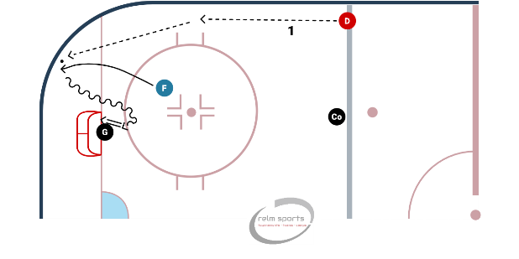
Description: Pucks start at the blue line.
- First player in line (F) skates down low
- Second player (D) rims a puck off the board (like a dump and chase)
- F picks the puck up (shoulder checks) and drives to the net (wrap near or far side)
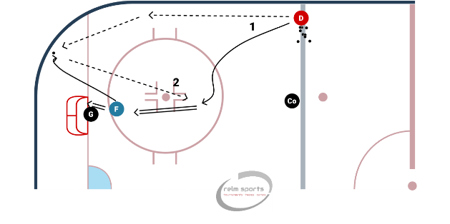
D rims a 2nd puck, and F retrieves it. D moves to the high slot. F passes it from the corner and drives the net for a rebound.
WHY? | Puck retrieval and attacking the net
Key Teaching &  Execution Points: | Try to teach them to shoulder check before going into the corner.

Drill #3: Lo-Hi Shot Walk the Line | Coach: one per side, control flow | Time: 8 min
Goalie Purpose: face shot |  | Work/Rest Ratio: med intensity, med rest
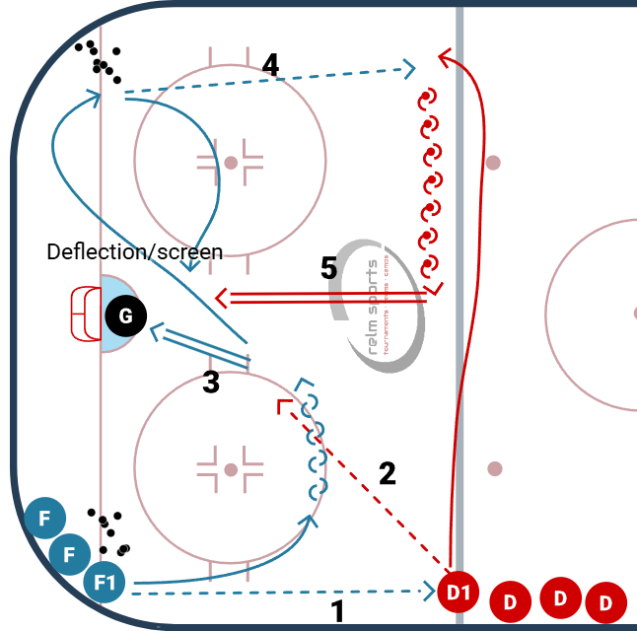
Description:
- Puck starts in each corner. Forward grabs a puck, passes the puck to the point. Then skates above the circle, pivots to catch a pass from the D (in step 2)
- Defense steps up, and moves the puck to the slot.
- Forward shoots on net (can try a 1T) from high slot
- Forward retrieves a puck from the opposite corner. Defense skates to opposite side after his pass and forward again passes from low to high
- Defense walks to the middle of ice. Forward positions for a screen/deflection. Defense rips a shot low from the point.

WHY? | Teaching low-high concept.
Key Teaching &  Execution Points: | Forward should pivot to catch pass 2  Review backwards xover with puck.  Explain why to walk the line.  Explain how to set a screen/deflection

