Ice 5 – July 6 8:30-9:30 Desjardin

Practice Objective
Work on puck protection and offensive zone control

Timeline
Time | Allotted  (min) | Phase | Drill | Details | Goalie
8:30 | 8 min | Individual tactic | 1 v 1 puck protect circle | Review Mohawks | Stretch/Face shots
8:38 | 7 min | Individual tactic | Continuous Cycle Drill |  | Face shots
8:45 | 5 min | Individual Skill | Backwards crossover circles |  | Face shots
8:50 | 8 min | Individual tactic | Low-hi walk the line |  | Face shots
8:58 |  | Scrimmage |  |  | Face shots

Drill #1: 1 v 1 puck protect circle | Coach: one per side, control flow | Time: 8 min
Goalie Purpose: face shot |  | Work/Rest Ratio: High intensity,high/med rest
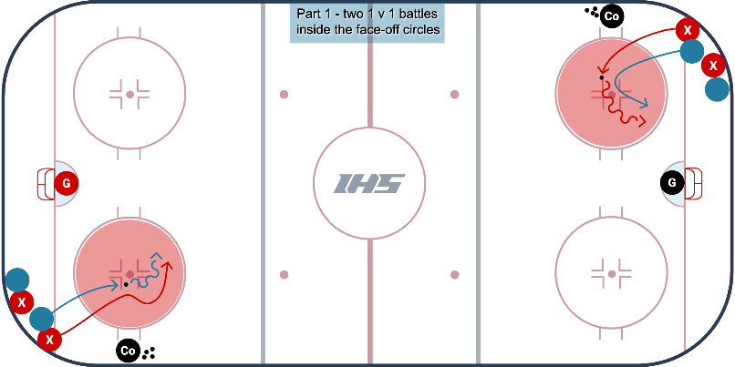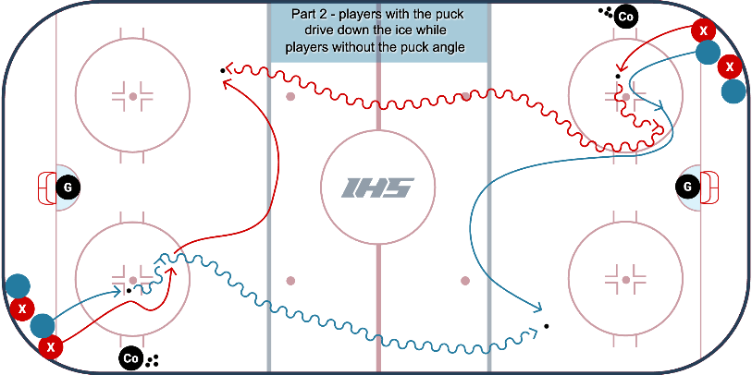Description:
- Players in opposite corners of the ice.
- On the first whistle, 2 players from the corner battle for the loose puck inside the face-off circle.
- On the second whistle, the player with the puck, or the player that last touched the puck, takes the puck down the ice, while the player without the puck gets up ice and looks to angle the other puck carrier coming down the ice.
- The forward with the puck can NOT cut to the middle of the ice until they pass the red line.

https://www.icehockeysystems.com/hockey-drills/circle-puck-protect

WHY? | Use body to protect puck
Key Teaching &  Execution Points: | Review mohawk technique to shield the puck, quick small area change of direction.

Drill #2: Continuous Cycle Dril | Coach: one per side, control flow | Time: 8 min
Goalie Purpose: face shot |  | Work/Rest Ratio: med intensity, med rest
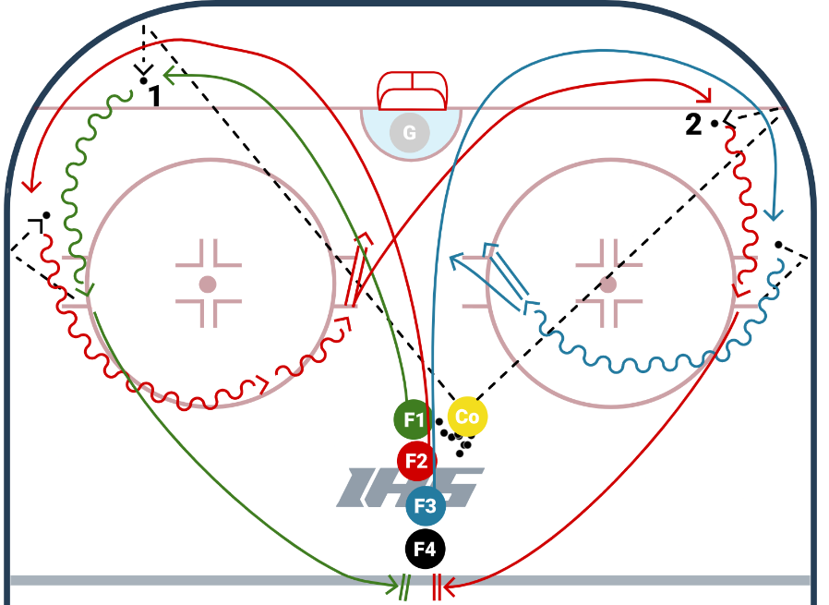
Description:
- Lineup at least 4 deep. Coach chips the puck in the corner, first player picks it up, and second player trails
- Second player trails the first and CALLS for a PASS/CYCLE. The first player chips it back off the boards
- Player that chips it returns to the end of the line, the player that catches the cycle releases a shot from the slot and the coach chips a puck to the opposite corner
- The shooter now becomes the cycle passer, and the player from the line becomes the shooter
- REPEAT

https://www.icehockeysystems.com/hockey-drills/continuous-cycle-drill-0
WHY? | Teaching the concept of cycling /puck control
Key Teaching &  Execution Points: | Forward should use their body and work on protecting the puck along the boards. Do not expose the puck to the middle of the ice  The forward that shoots should take a quick shot

Drill #3: Lo-Hi Shot Walk the Line | Coach: one per side, control flow | Time: 8 min
Goalie Purpose: face shot |  | Work/Rest Ratio: med intensity, med rest
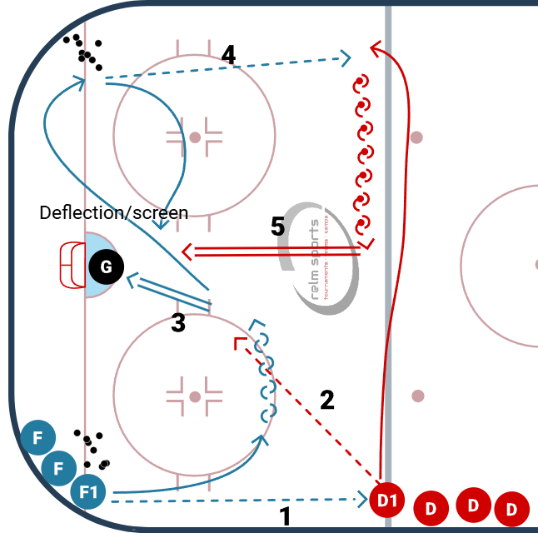
Description:
- Puck starts in each corner. Forward grabs a puck, passes the puck to the point. Then skates above the circle, pivots to catch a pass from the D (in step 2)
- Defense steps up, and moves the puck to the slot.
- Forward shoots on net (can try a 1T) from high slot
- Forward retrieves a puck from the opposite corner. Defense skates to opposite side after his pass and forward again passes from low to high
- Defense walks to the middle of ice. Forward positions for a screen/deflection. Defense rips a shot low from the point.

WHY? | Teaching low-high concept.
Key Teaching &  Execution Points: | Forward should pivot to catch pass 2  Review backwards xover with puck.  Explain why to walk the line.  Explain how to set a screen/deflection

