Ice 4 – June 28 9 -10 AM Selkirk

Practice Objective
Work on cycling and offensive zone puck movement

Timeline
Time | Allotted  (min) | Phase | Drill | Details | Goalie
9:00 | 8 min | Individual skill | Corkscrew skating + anchoring |  | Stretch/Face shots
9:15 | 7 min | Individual skill | Datsyuk Shooting |  | Face shots
9:22 | 8 min | Individual tactic | Continuous Cycle Drill  – basic version | Explain why to cycle | Face shots
9:30 | 8 min | Mini Game | 3 v 3 World’s Greatest Drill |  | Face shots
9:38 | 12 min | Scrimmage |  |  | Face shots

Drill #2: Datsyuk Shooting | Coach: one per side, control flow | Time: 8 min
Goalie Purpose: face shot |  | Work/Rest Ratio: med intensity, med rest
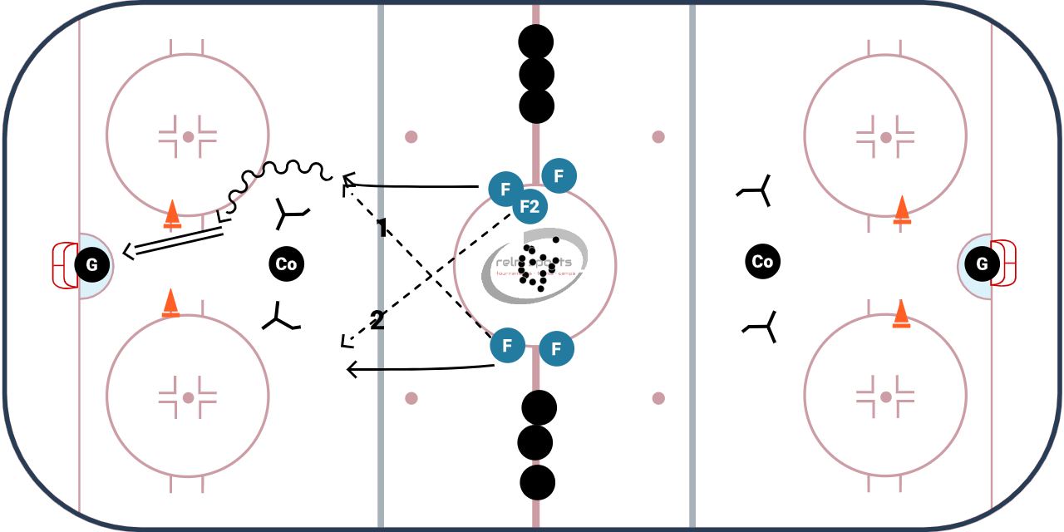Description:
2 Lines of players
4 obstacles (cones) set in a rectangle in line with the players
- Player catches a pass from the other line
- Player with puck attacks the first cone to the outside
- Player pulls the puck inside the next cone and shoots in stride

https://www.icehockeysystems.com/hockey-drills/datsyuk-shooting-12
WHY? | Works on catching a pass and immediately attacking the net and shooting
Key Teaching &  Execution Points: | Try to use deception/head fake when deking the first cone  Shoot while in stride and shifting body weight

Drill #3: Continuous Cycle Drill | Coach: one per side, control flow | Time: 8 min
Goalie Purpose: face shot |  | Work/Rest Ratio: med intensity, med rest
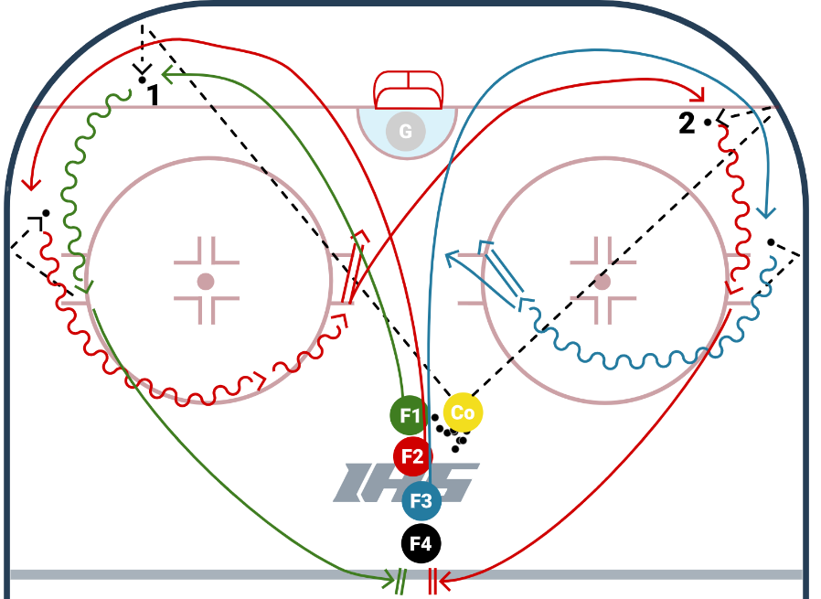
Description:
- Lineup at least 4 deep. Coach chips the puck in the corner, first player picks it up, and second player trails
- Second player trails the first and CALLS for a PASS/CYCLE. The first player chips it back off the boards
- Player that chips it returns to the end of the line, the player that catches the cycle releases a shot from the slot and the coach chips a puck to the opposite corner
- The shooter now becomes the cycle passer, and the player from the line becomes the shooter
- REPEAT

https://www.icehockeysystems.com/hockey-drills/continuous-cycle-drill-0

WHY? | Teaching the concept of cycling /puck control
Key Teaching &  Execution Points: | Forward should use their body and work on protecting the puck along the boards. Do not expose the puck to the middle of the ice  The drop pass should have enough of an angle so the second forward can easily pick it up off of the boards.  The forward that shoots should take a quick shot

Drill #4: 3 v 3 World’s Greatest drill | Coach:  Coaches act as pointman on each end | Time: 8 minutes
Goalie Purpose: face shot |  | Work/Rest Ratio: High intensity, high rest
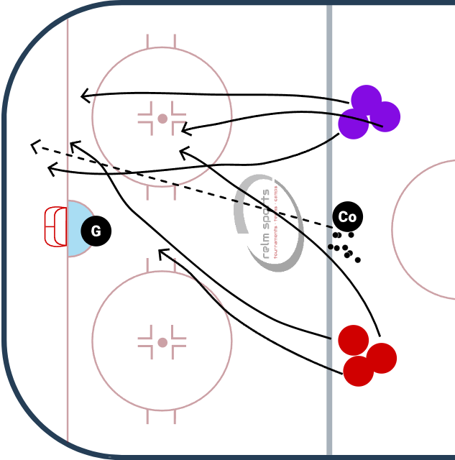
Description:
Puck starts with the coach. Dumps it in a corner or shoots it on net. Teams of 3 battle for the puck.
BUT Rules of the game are
1) every turnover needs to be cleared back to the coach (regroup)
2) all teammates have to touch the puck on each possession before a goal

WHY? | Works on offensive zone puck movement, creating turnovers, and low-high concept
Key Teaching &  Execution Points: | Form triangles for passing lanes. Move to open space and move the puck.

