Ice 3 – June 22 9 -10 AM Selkirk

Practice Objective
Work on passing, puck movement and defending

Timeline
Time | Allotted  (min) | Phase | Drill | Details | Goalie
9:00 | 6 min | Warmup  Skill develop: skating | Skating/Stride mechanics | 1) Single leg extension and hold  2) single skate  3) butt to ice  4) Witches broom  5) Chariot pull x2 | Warmup/stretch
9:06 | 2 min | waterbreak
9:08 | 7 min | Skill develop: passing | Passing geometry | 1) forehand to forehand  2) backhand to backhand  3) follow pass | Face shots
9:15 | 7 min | Mini Game | 4 v 2 Swiss Drill |  | Face shots
9:22 | 8 min | Individual Tactic | 3 v 3 World’s Greatest Drill |  | Face shots
9:30 | 20 min | Scrimmage |  |  | Face shots

Drill #2: Passing Geometry | Coach: one per side, control flow | Time: 8 min
Goalie Purpose: face shot |  | Work/Rest Ratio: low intensity, low/med rest
Description:

WHY? | Conditioning, teaching basic backcheck concept
Key Teaching &  Execution Points: | Defense split the difference/play the pass until backchecker engages, force puck outside  Backchecker starts middle, but moves to the player without the puck  Communication defender points who he will take  Attackers try to move the puck up ice and to the middle

Drill #3: 4 v 2 Swiss | Coach: one per side, control flow | Time: 8 min
Goalie Purpose: face shot |  | Work/Rest Ratio: low intensity, low/med rest
Description:

WHY? | Conditioning, teaching basic backcheck concept
Key Teaching &  Execution Points: | Defense split the difference/play the pass until backchecker engages, force puck outside  Backchecker starts middle, but moves to the player without the puck  Communication defender points who he will take  Attackers try to move the puck up ice and to the middle

Drill #4: 3 v 3 World’s Greatest drill | Coach:  Coaches act as pointman on each end | Time: 8 minutes
Goalie Purpose: face shot |  | Work/Rest Ratio: High intensity, high rest
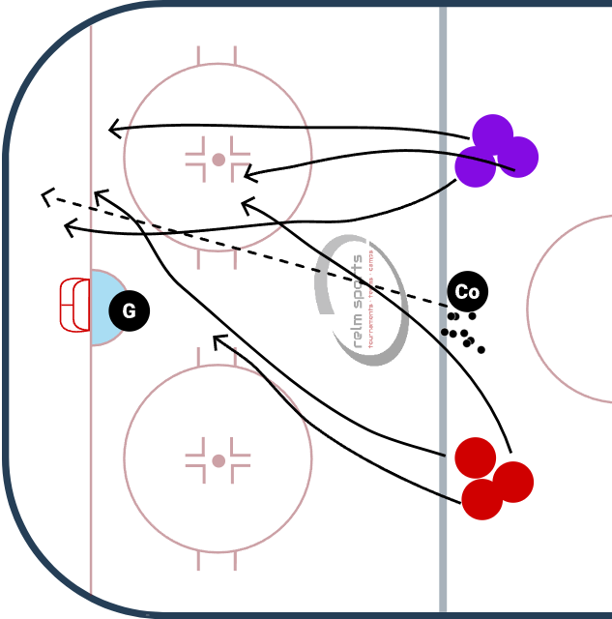
Description:
Puck starts with the coach. Dumps it in a corner or shoots it on net. Teams of 3 battle for the puck.
BUT Rules of the game are
1) every turnover needs to be cleared back to the coach (regroup)
2) all teammates have to touch the puck on each possession before a goal

WHY? | Works on offensive zone puck movement, creating turnovers, and low-high concept
Key Teaching &  Execution Points: | Form triangles for passing lanes. Move to open space and move the puck.

