Ice 2 – June 15 9 -10 AM Desjardins

Practice Objective
Work on skating + offensive zone puck movement

Timeline
Time | Allotted  (min) | Phase | Drill | Details | Goalie
9:00 | 4 min | Individual Skill Warmup | Crossover circles | forward 1x w/puck  backward 1x w/puck | Warmup/stretch
9:04 | 8 min | Individual Tactic | Redwing 1-2-1 Backcheck Drill |  | Face shots
9:12 | 1 min | waterbreak
9:13 | 7 min | Individual Tactic | Neutral zone regroup to wide drive 2 on 1 |  | Face shots
9:20 | 8 min | Mini game | 3 vs 3 World’s greatest drill |  | Face shots
9:28 | 5 min | Conditioning | Windsprint | 1x rep | conditioning
9:32 |  | Scrimmage |  |  | Face shots

Drill #2: Redwing 1-2-1 Backcheck Drill | Coach: one per side, control flow | Time: 8 min
Goalie Purpose: face shot |  | Work/Rest Ratio: high intensity, low/med rest
Description:
- Puck starts with forward at bottom of circle, makes a pass to the board side forward
- The two forwards on the hash now skate up 2 on 1 against the defender at the top of the circle, while the forward that started the drill backchecks
https://www.icehockeysystems.com/hockey-drills/red-wing-2-v-1-backchecker

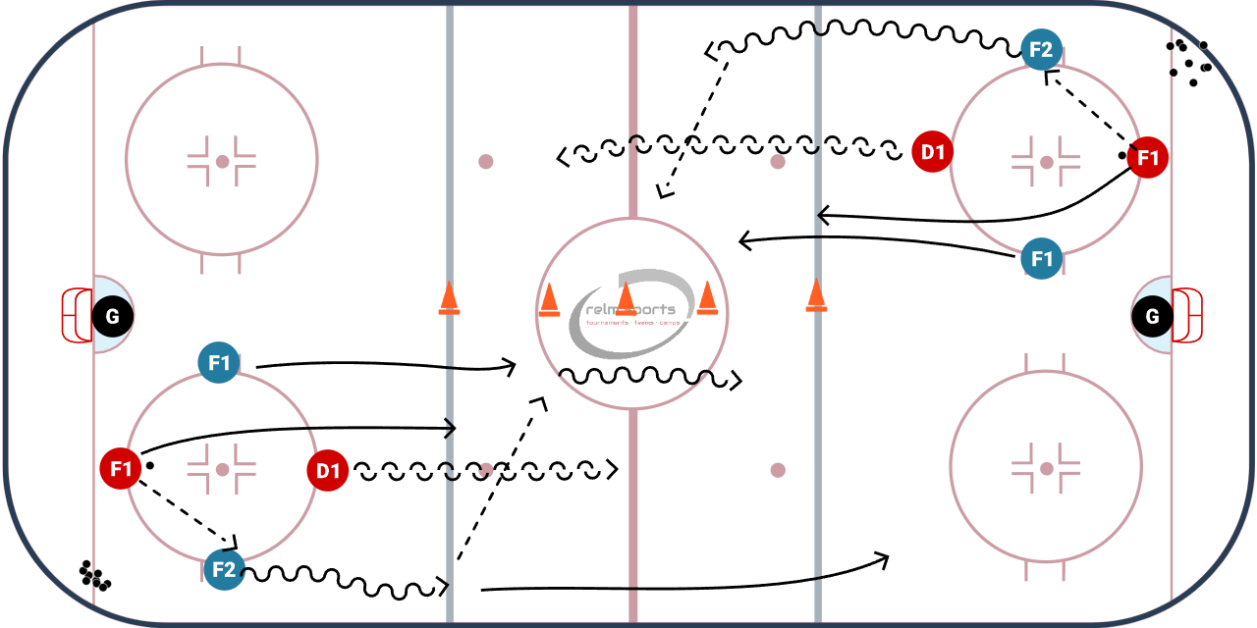

WHY? | Conditioning, teaching basic backcheck concept
Key Teaching &  Execution Points: | Defense split the difference/play the pass until backchecker engages, force puck outside  Backchecker starts middle, but moves to the player without the puck  Communication defender points who he will take  Attackers try to move the puck up ice and to the middle
Drill #3 – Neutral zone regroup to wide drive  2 on 1 | Coach:  One coach controls with whistle, other coaches help with timming | Time: 10 minutes  2 min instruction 4 minutes each side
Goalie Purpose: face shots/dekes |  | Work/Rest Ratio: high int med rest
Description: Builds off the previous week’s drill
- Whistle blows, forward F1 starts with the puck, makes a pass to the opposite side defense D1
- D1 catches the pass and makes a cross ice pass to other D2, forwards curls and builds speed
- Cross ice D2 catches the pass and makes a shorter pass (ahead and outside) of the forward.
- Original D1 now gaps up, and faces forwards 2 on 1. Forward wide drives to the net
Consider different types of attack: (1) F2 trails, (2) F2 drives to the net, F1 can curl to buy time

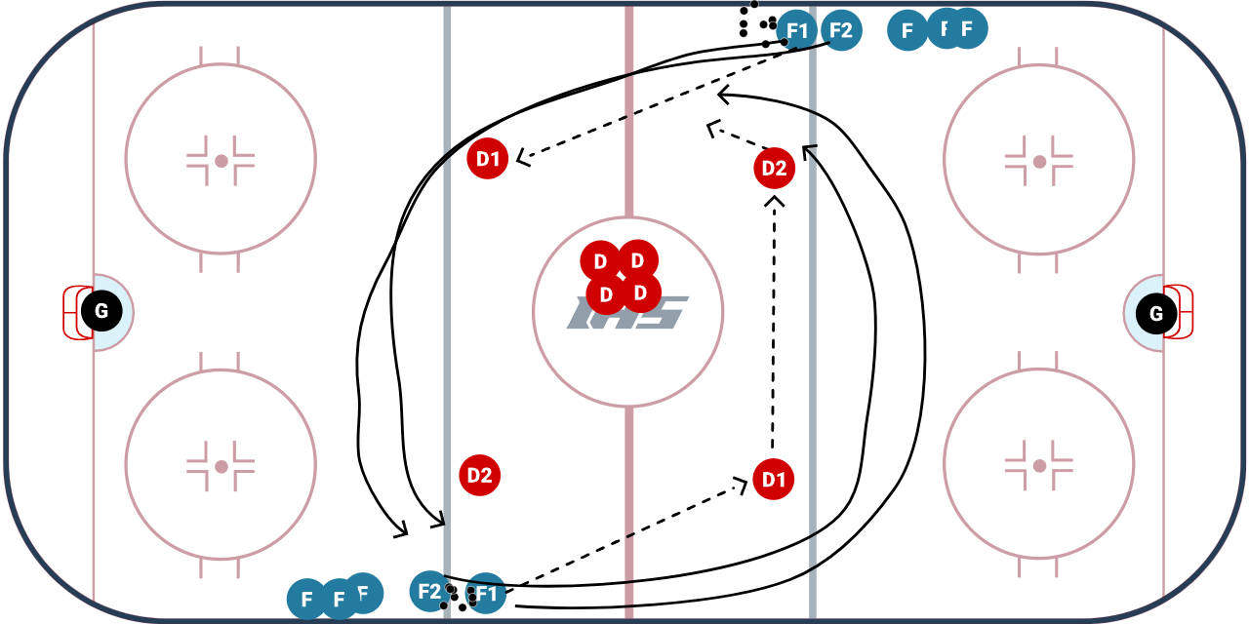
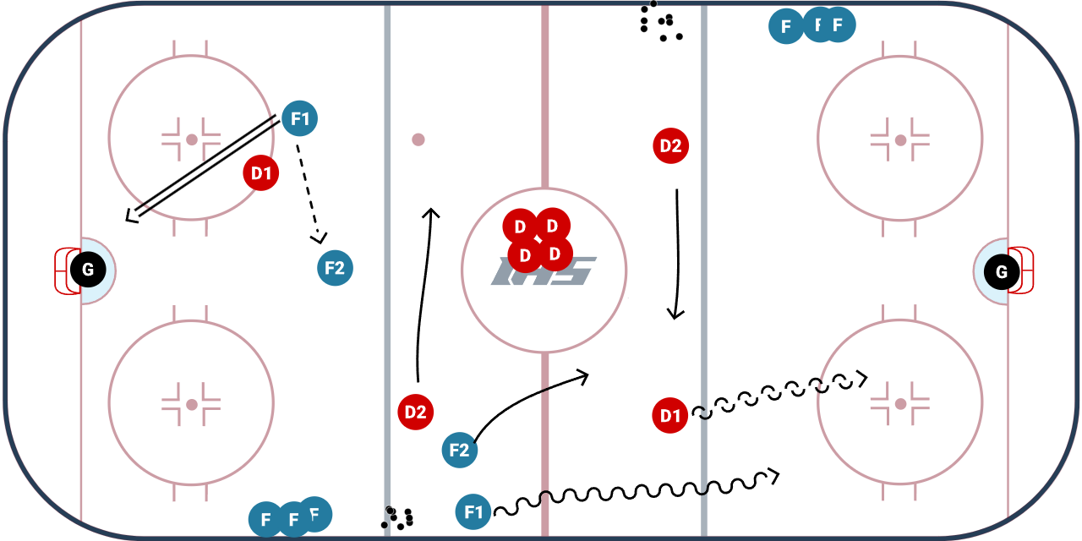

WHY? | Works neutral zone regroup, stretching the ice width wise. Building speed through the neutral zone, and work wide drive skills
Key Teaching &  Execution Points: | 1) Forwards NEED to build speed in the neutral zone. First move should be beating the D wide and driving the net.  2) Better development forwards need to learn how to use an odd number rush  3) Defense uses same skills learned in previous backcheck drill, but without the support of a backchecker

Drill #4: 3 v 3 World’s Greatest drill | Coach:  Coaches act as pointman on each end | Time: 8 minutes
Goalie Purpose: face shot |  | Work/Rest Ratio: High intensity, high rest
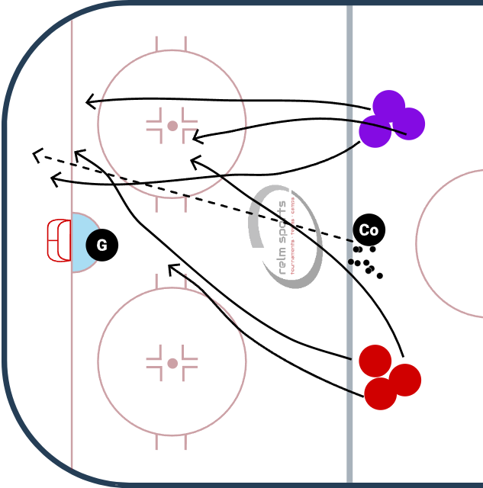
Description:
Puck starts with the coach. Dumps it in a corner or shoots it on net. Teams of 3 battle for the puck.
BUT Rules of the game are
1) every turnover needs to be cleared back to the coach (regroup)
2) all teammates have to touch the puck on each possession before a goal

WHY? | Works on offensive zone puck movement, creating turnovers, and low-high concept
Key Teaching &  Execution Points: | Form triangles for passing lanes. Move to open space and move the puck.

