Ice 10 – Saturday August 23 9 to 10 AM Selkirk

Practice Objective
Individual skills

Timeline
Time | Allotted  (min) | Phase | Drill | Details | Goalie
9:00 | 8 min | Individual Skills | Ricky Bobby | Review shooting + catching a pass | Face shot
 |  | 2 hard laps + water
9:10 | 8 min | Individual Skills | Stretch pass overspeed |  | Face shots
 |  | 2 hard laps + water
9:20 | 8 min | Mini -game | 4 v 2 Swiss drill | Review stick positioning | Face Shots
9:28 | 22 min | Scrimmage

Drill #1 – Ricky Bobby | Coach: one coach each end to control flow | Time: 8 minutes
Goalie Purpose: face shots |  | Work/Rest Ratio: med intensity high rest
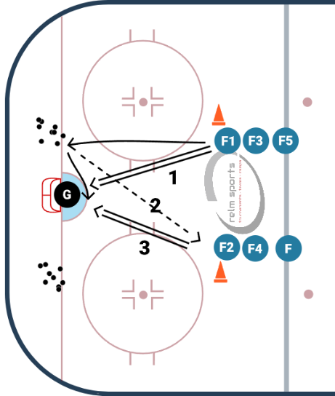
Description:
Two lines
First player starts off with a shot
- Once the player (F1) has shot the puck. They skate to their puck pile on their side
- They retrieve a puck make a pass to the first player in the adjacent line (F2)
- That player catches the puck and immediately shoots a puck that F1 tries to deflect or get a rebound.
- F2 repeats the process that F1 did, with F3.

WHY? | Work on passing to the slot and quick shot release and deflections/rebounds
Key Teaching &  Execution Points: | Review passing technique and body positioning for shooting

Drill #2: Stretch Pass overspeed | Coach:  Coach make sure the timing works using a whistle | Time: 8 minutes
Goalie Purpose: face shot |  | Work/Rest Ratio: High intensity, high rest
Description:
- Pucks start in opposite corners
- Whistle: skater one goes to the 1st cone, two goes to 2nd, and 3 goes to 3rd
- Next three in same line make stretch passes to the skaters as they curl
- Skaters catch the pass and come in with speed and shoot on the goalie
- Whistle and the opposite side now does the drill, shooters go into back of their line

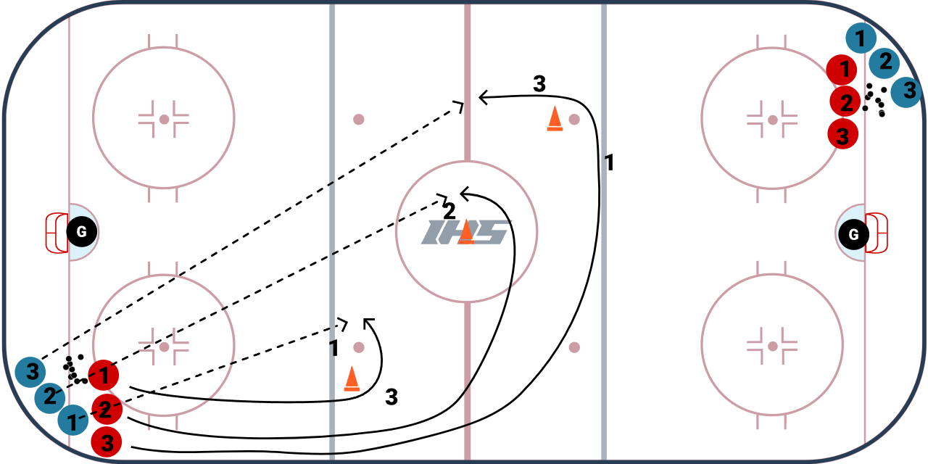
WHY? | Skating with speed. This should be done at max speed  Works stretch passing
Key Teaching &  Execution Points: | Emphasis on skating with speed.  Passing review technique on giving: head up, aim ahead of skater on tape/stick side. Push out with puck starting on heel  Catching pass, emphasis on catching it out in front

