Ice 1 – June 1

Practice Objective
Work on skating and skating with the puck + conditioning. Review Wide drive and gap control

Timeline
Time | Allotted  (min) | Phase | Drill | Details | Goalie
8:30 | 7 | Warmup | forward crossover circles | 2 minutes intro | Stretch, skate around
8:37 | 8 | Warmup: Individual Skill | 3 crossover drill |  | Face shots
8:45 | 10 | Individual Tactic | Neutral zone regroup to wide drive | 2 minutes explain wide drive and gap control | Face shots
8:55 | 10 | Individual Skill | Stretch Pass Overspeed | Cap it at 9:05 hard | Face shots
9:05 | 15 | Scrimmage

Drill #2: 3 crossover drill | Coach: One at each end of the line (help clear the pucks, correct technique, and make sure there is the right spacing/timing) | Time: 2x4 minutes  (reverse direction midway)
Goalie Purpose: face shot |  | Work/Rest Ratio: high intensity, low rest
Description: start with a puck and carry it with top speed using (ideally) 3 crossovers (in alternating direction) between cones. Shoot when exiting the last cone (try to translate skating speed into shot)

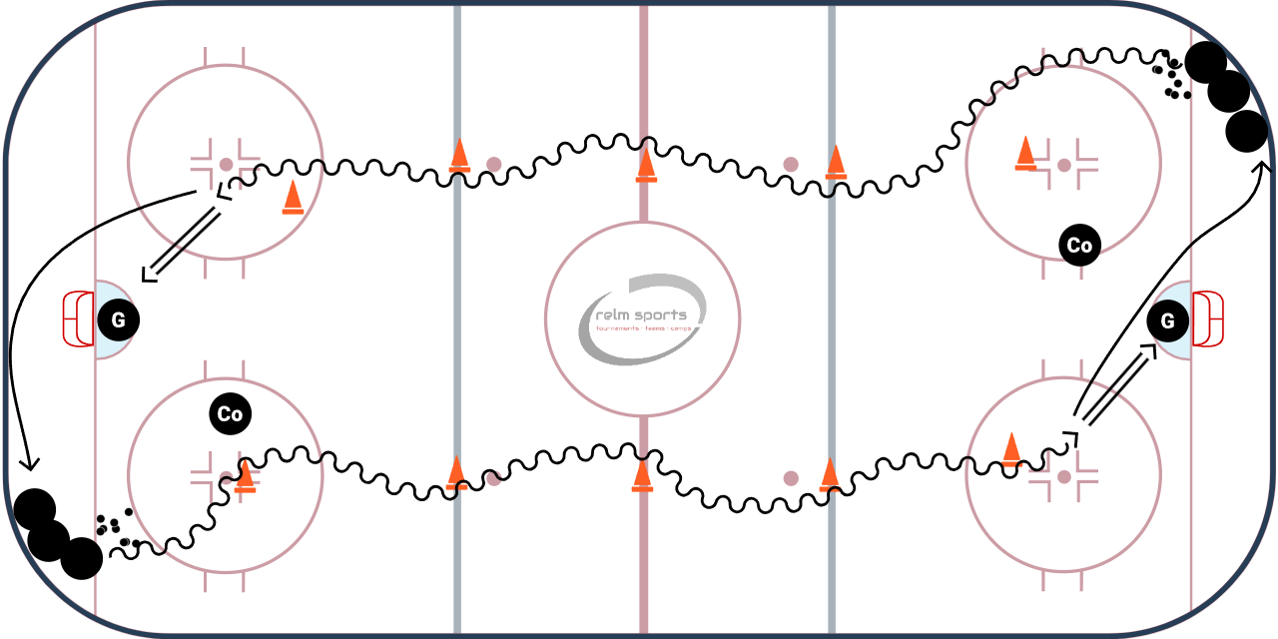

sWHY? | Practice carrying the puck with speed, using crossovers to build velocity and make angling hard
Key Teaching &  Execution Points: | Correct skating posture on crossovers, engaging the push under. Focus on rapid foot movement, DO NOT over stickhandle the puck, cradle puck

Drill #3 – Neutral zone regroup to wide drive | Coach:  One coach controls with whistle, one | Time: 10 minutes  2 min instruction 4 minutes each side
Goalie Purpose: face shots/dekes |  | Work/Rest Ratio: high int med rest
Description:
- Whistle blows, forwards make a pass to the opposite side D
- D catches the pass and makes a cross ice pass to other D, forward curls and builds speed
- Cross ice D catches the pass and makes a shorter pass (ahead) of the forward.
- Original D now gaps up, and faces forward 1 on 1. Forward wide drives to the net
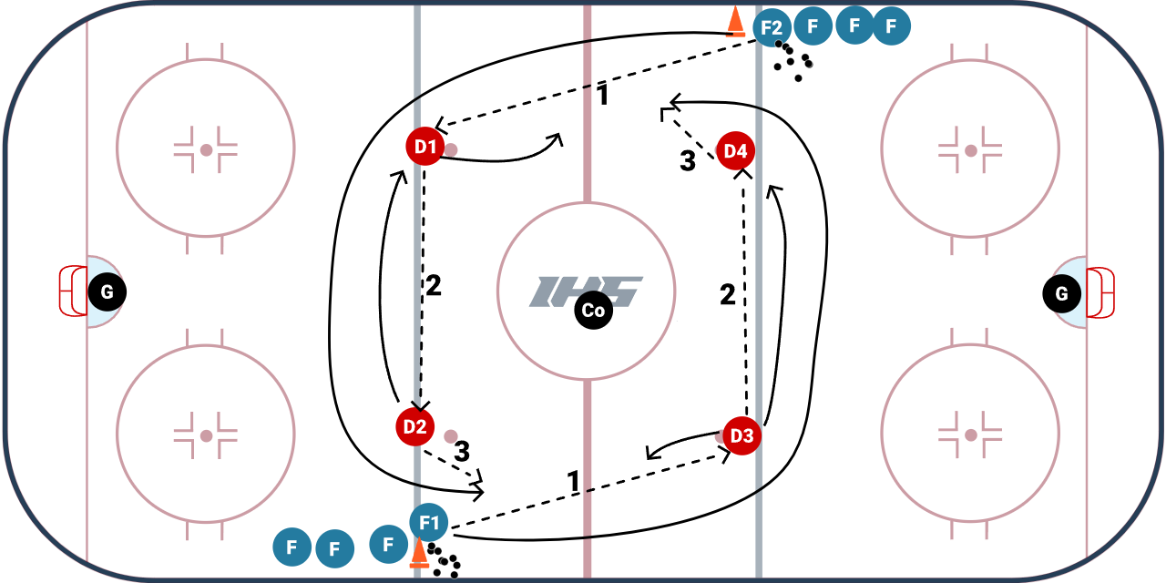

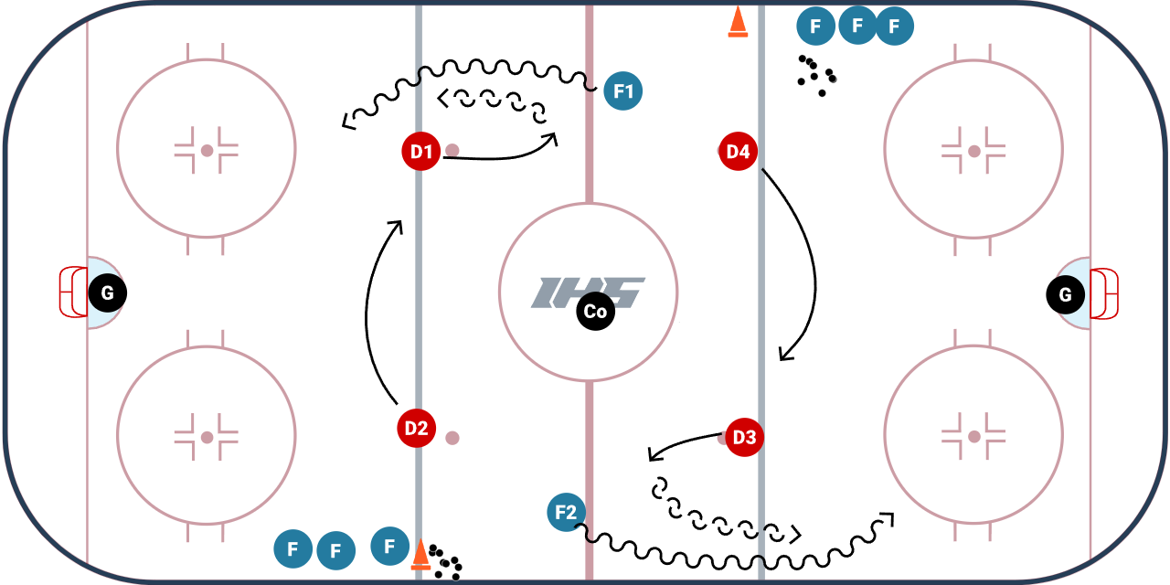
WHY? | Works neutral zone regroup, stretching the ice width wise. Building speed through the neutral zone, and work wide drive skills
Key Teaching &  Execution Points: | 1) Forwards NEED to build speed in the neutral zone. First move should be beating the D wide and driving the net.  2) Better development forwards need to realize when the wide drive is not the best option and change pace trying to move to the middle or shoot through the D  3) Defense need to gap up and try to force the forward wide, review gap control and stick positioning. Do not skate straight back into goalie

Drill #3: Stretch Pass overspeed | Coach:  Coach make sure the timing works using a whistle | Time: 8 minutes
Goalie Purpose: face shot |  | Work/Rest Ratio: High intensity, high rest
Description:
- Pucks start in opposite corners
- Whistle: skater one goes to the 1st cone, two goes to 2nd, and 3 goes to 3rd
- Next three in same line make stretch passes to the skaters as they curl
- Skaters catch the pass and come in with speed and shoot on the goalie
- Whistle and the opposite side now does the drill, shooters go into back of their line

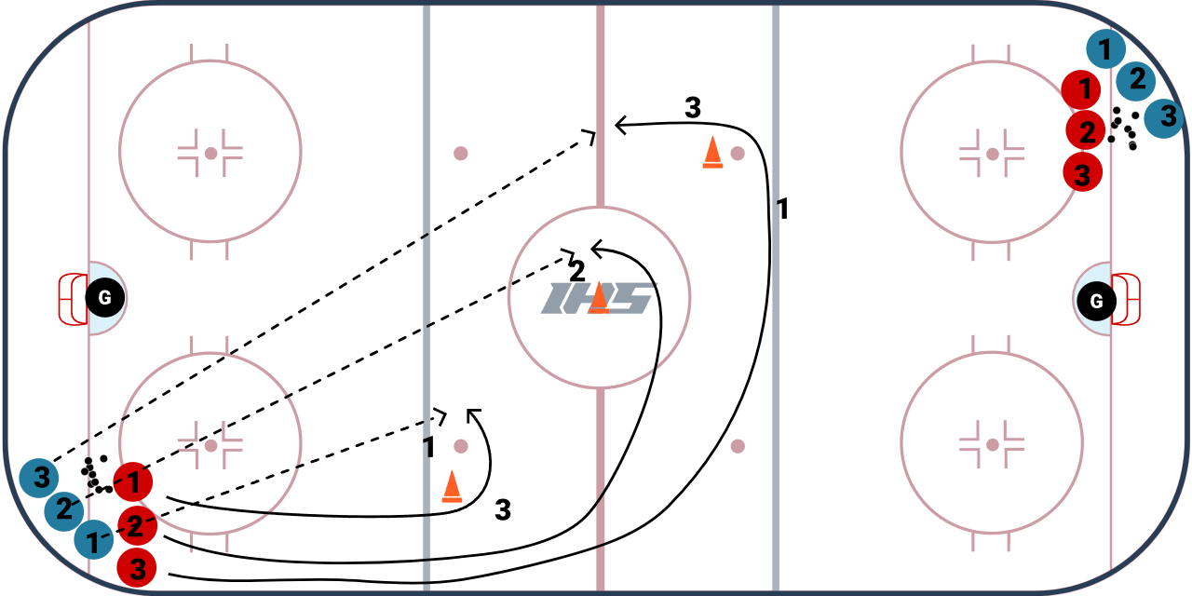
WHY? | Skating with speed. This should be done at max speed  Works stretch passing
Key Teaching &  Execution Points: | Emphasis on skating with speed.  Passing review technique on giving: head up, aim ahead of skater on tape/stick side. Push out with puck starting on heel  Catching pass, emphasis on catching it out in front

